Assignment-7

- Calculate the difference in days between two dates: 15th August 2025 and 1st January 2025.
import datetime
date_1 = datetime.date(2025,8,15)
date_2 = datetime.date(2025,1,1)
diff = date_2-date_1
print(f"The difference between {date_1} and {date_2} is: {abs(diff.days)} days")
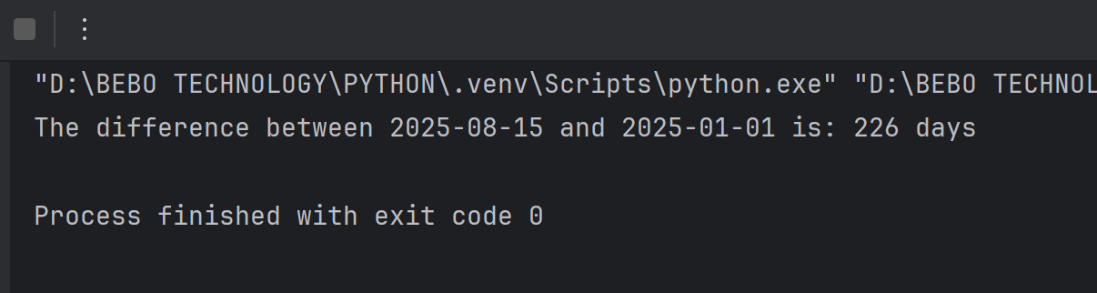

- Write a Counter class with a class variable count to keep track of how many objects have been created. Test this by creating multiple objects and printing the count.
class Counter:
count = 0
def __init__(self):
Counter.count+=1
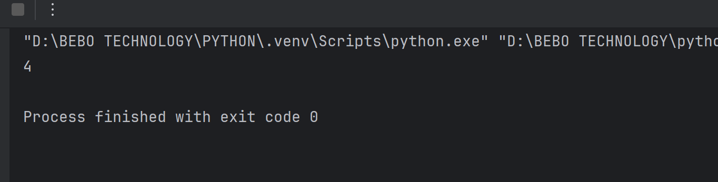
- Write a program to print the current date and time in the format YYYY-MM-DD HH:MM:SS. Create a datetime object for 1st January 2025, 12:00 PM and print it in the format Day Month, Year at HH:MM.
import datetime
now = datetime.datetime.now()
print(now)
date = datetime.datetime(2025,1,1,12,0)
# print(f"{date.day}-{date.month}-{date.year} at {time.hour}:{time.minute}")
print(date.strftime("%d %B %Y at %H:%M"))
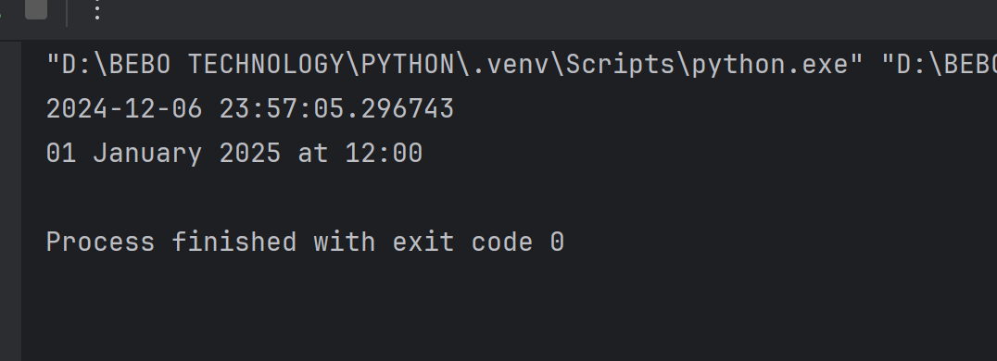

- Write a Product class with instance attributes for name and price. Add a class method set_discount(cls, discount) to apply a discount to all products. Use this class method to change the price of all created products.
class Product:
discount = 0
def __init__(self, name, price):
self.name = name
self.price = price
@classmethod
def set_discount(cls, discount):
cls.discount = discount
def get_discounted_price(self):
return self.price * (1 - self.discount / 100)
# Example usage
product1 = Product("Laptop", 1000)
product2 = Product("Smartphone", 500)
print("Original Prices:")
print(f"{product1.name}: {product1.price}")
print(f"{product2.name}: {product2.price}")
# Apply a discount
Product.set_discount(10)
print("\nPrices After 10% Discount:")
print(f"{product1.name}: {product1.get_discounted_price()}")
print(f"{product2.name}: {product2.get_discounted_price()}")
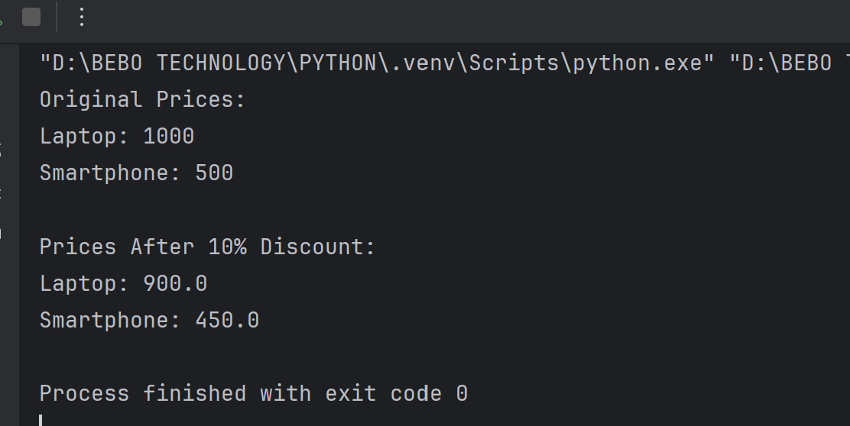
- Create a class Car with:
- An instance variable brand
- A class variable wheels initialized to 4
- Add a method show() to print both variables.
class Car:
wheels = 4
def __init__(self,brand):
self.brand = brand
def show(self):
print(f"Brand: {self.brand}, Wheels = {self.wheels}")
car1 = Car("Toyota")
car1.show()
car2 = Car("Tata")
car2.show()
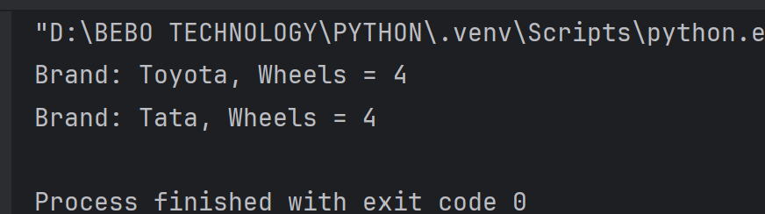

- Write a program to add 30 days to the current date and print the result.
import datetime
now = datetime.datetime.now()
add = now+datetime.timedelta(days=30)
print("After adding 30days: ",add.date())
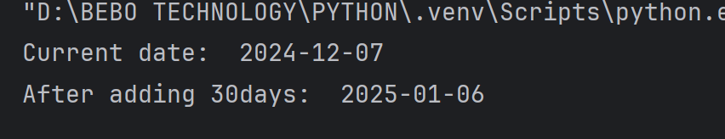
- Extend the Car class to include a method delete_attribute(attr_name) that checks if the attribute exists before deleting it. Print an appropriate message if the attribute does not exist.
class Car:
wheels = 4
def __init__(self, brand):
self.brand = brand
def show(self):
print(f"Brand: {self.brand}, Wheels: {Car.wheels}")
def delete_attribute(self, attr_name):
if hasattr(self, attr_name):
delattr(self, attr_name)
print(f"Attribute '{attr_name}' has been deleted.")
else:
print(f"Attribute '{attr_name}' does not exist.")
car1 = Car("Toyota")
car1.show()
car1.delete_attribute("brand")
car1.show() # This will throw an error since 'brand' no longer exists
car1.delete_attribute("color")
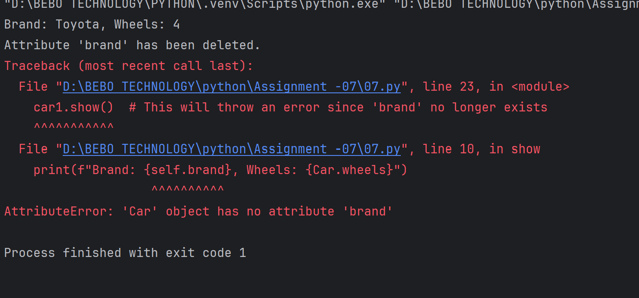
- Create a class Book with a constructor that initializes the title. Override the del method to print a message when the object is deleted. Create and delete a Book object to demonstrate this.
class Book:
def __init__(self, title):
self.title = title # Initialize the title attribute
def display(self):
print(f"Title: {self.title}")
def __del__(self):
print(f"The book '{self.title}' has been deleted.")
# Demonstration Block 1
ob1 = Book("The Great Gatsby")
ob2 = Book("1984")
ob1.display()
ob2.display()
del ob1
del ob2
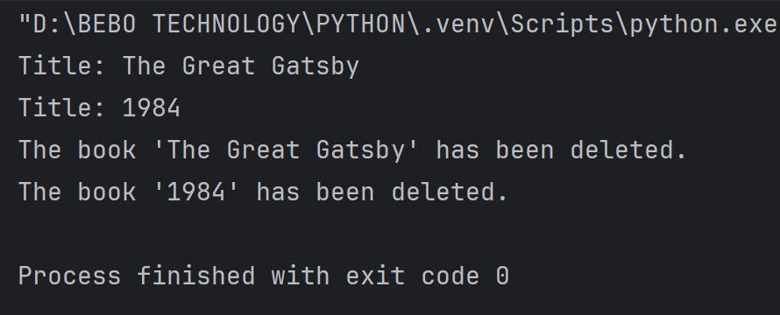
- Create a class Product with:
- A constructor that takes name and price.
- A class method from_discounted_price(name, discounted_price, discount_percentage) that initializes a product based on the discounted price.
- Demonstrate the use of both constructors.
class Product:
def __init__(self, name, price):
self.name = name
self.price = price
@classmethod
def from_discounted_price(cls, name, discounted_price, discount_percentage):
original_price = discounted_price / (1 - discount_percentage / 100)
return cls(name, original_price)
def display(self):
print(f"Product Name: {self.name}, Price: {self.price}")
product1 = Product("Laptop", 1000)
product1.display()
product2 = Product.from_discounted_price("Smartphone", 800, 20)
product2.display()

